**Unit Testing (Test individual code / function/ component )**

**Both Jest and Enzyme are meant to test the react applications**. Jest can be used with any other Javascript framework, but Enzyme is meant to run on react only. Jest can be used without Enzyme, and snapshots can be created and tested perfectly fine. But the Enzyme adds additional functionality to it.

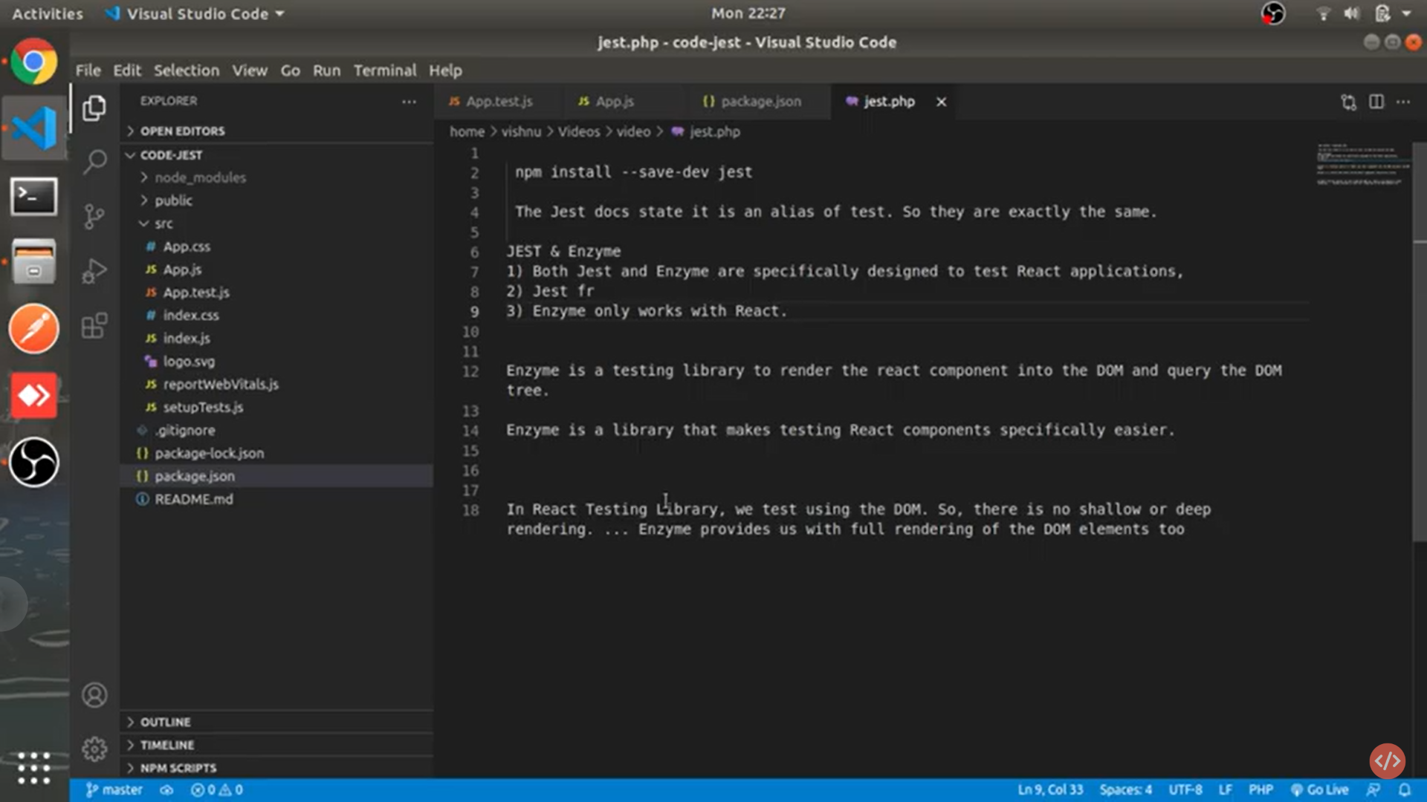

Jest is a framework

Enzyme is a library that is used to test react compo easily

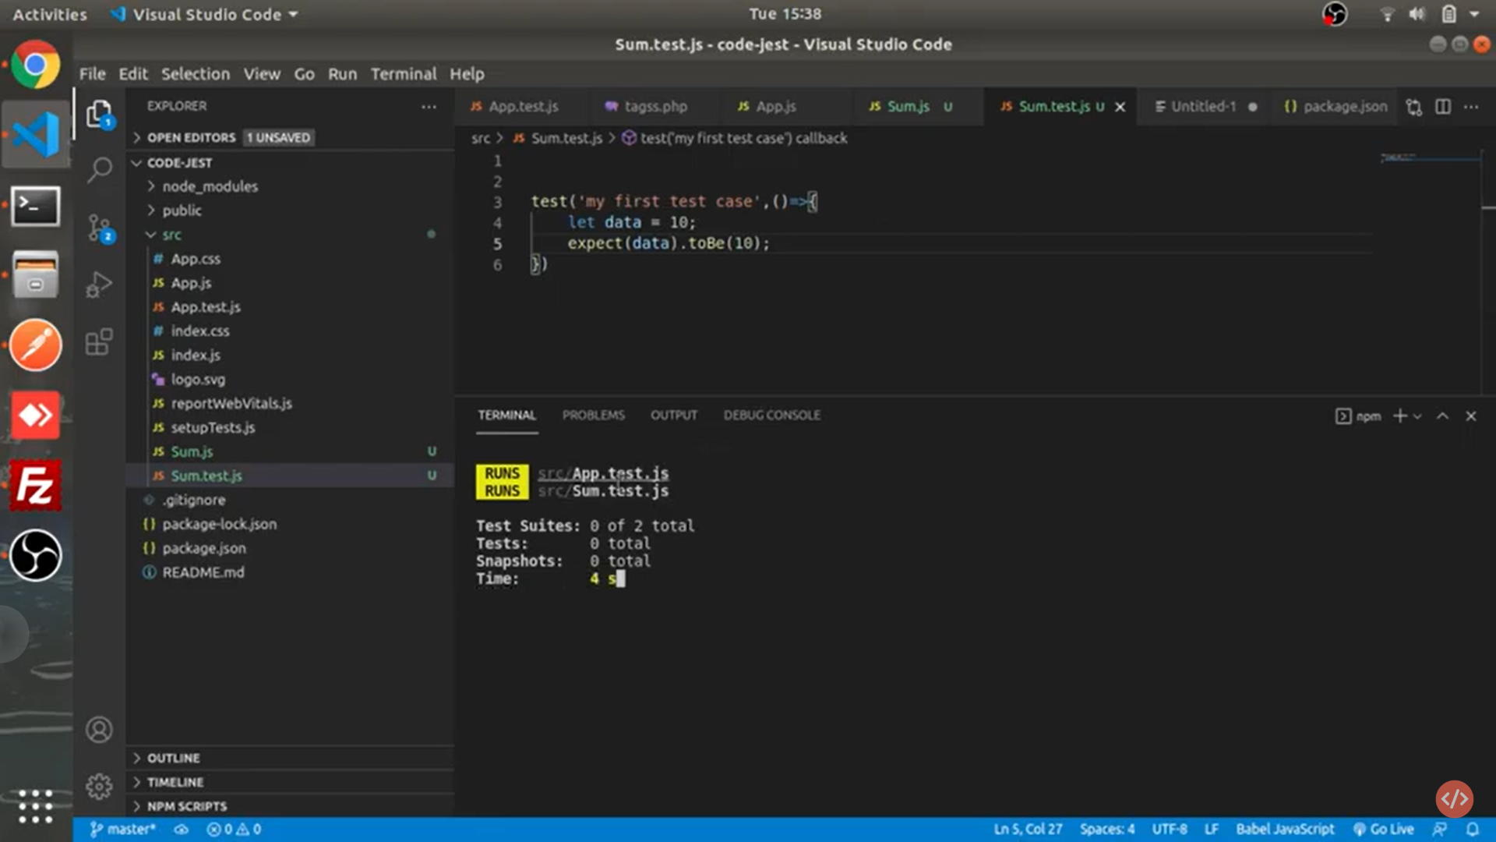

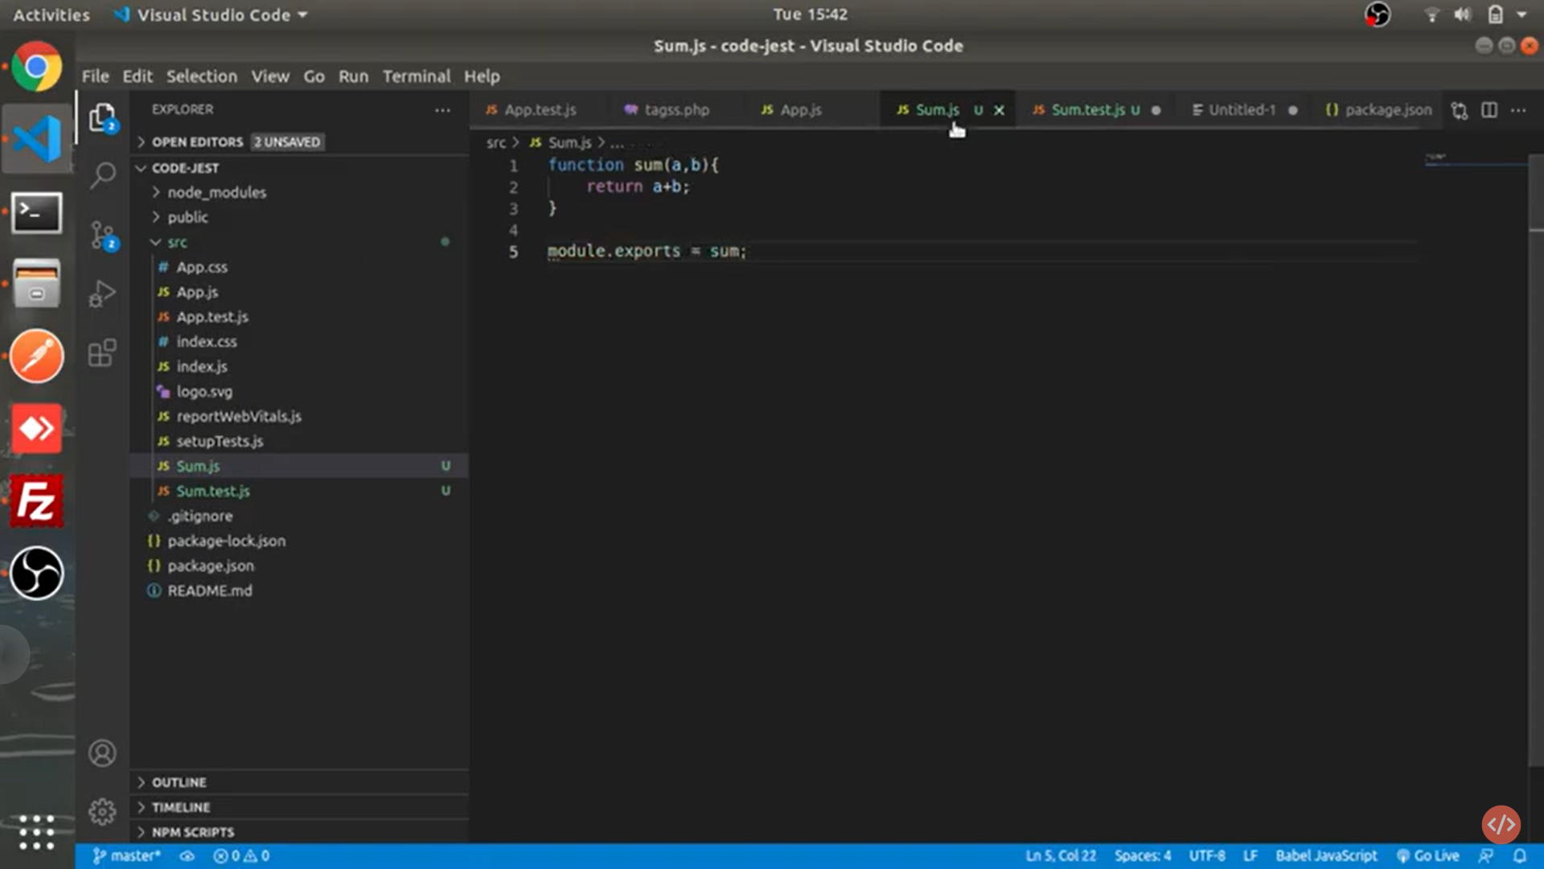

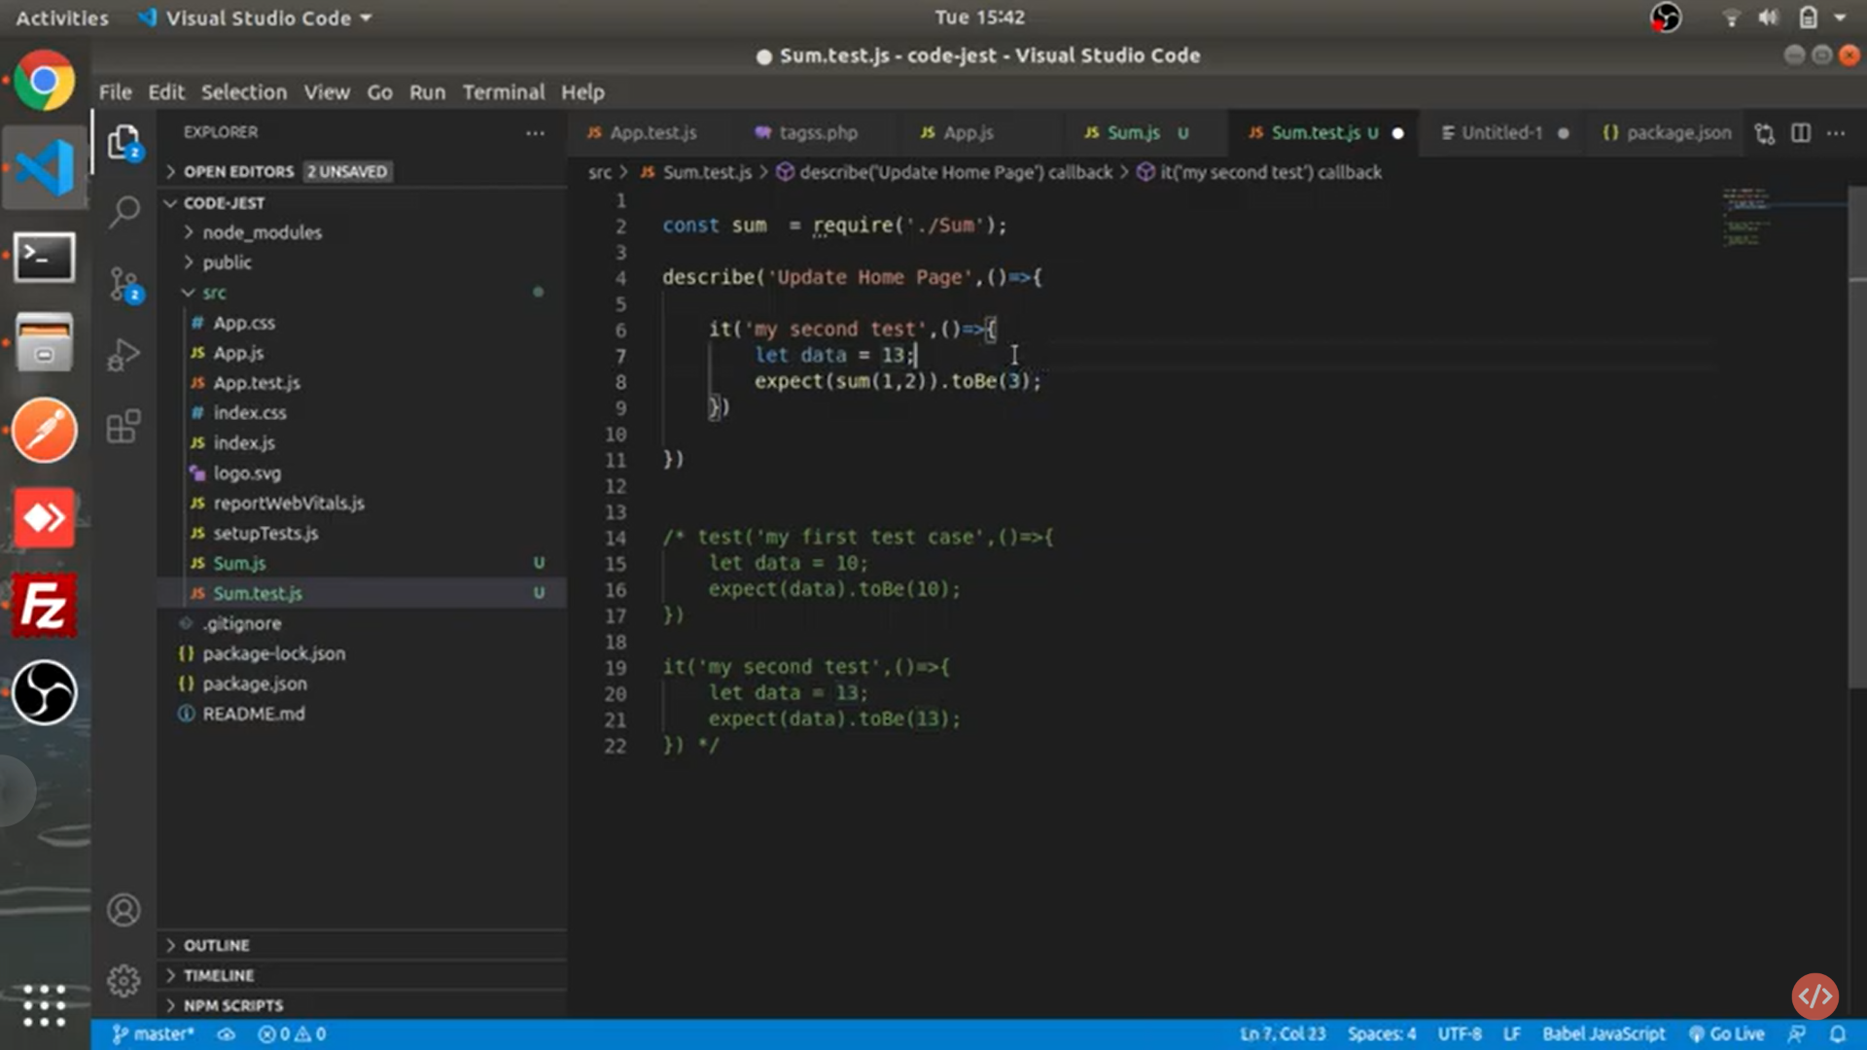

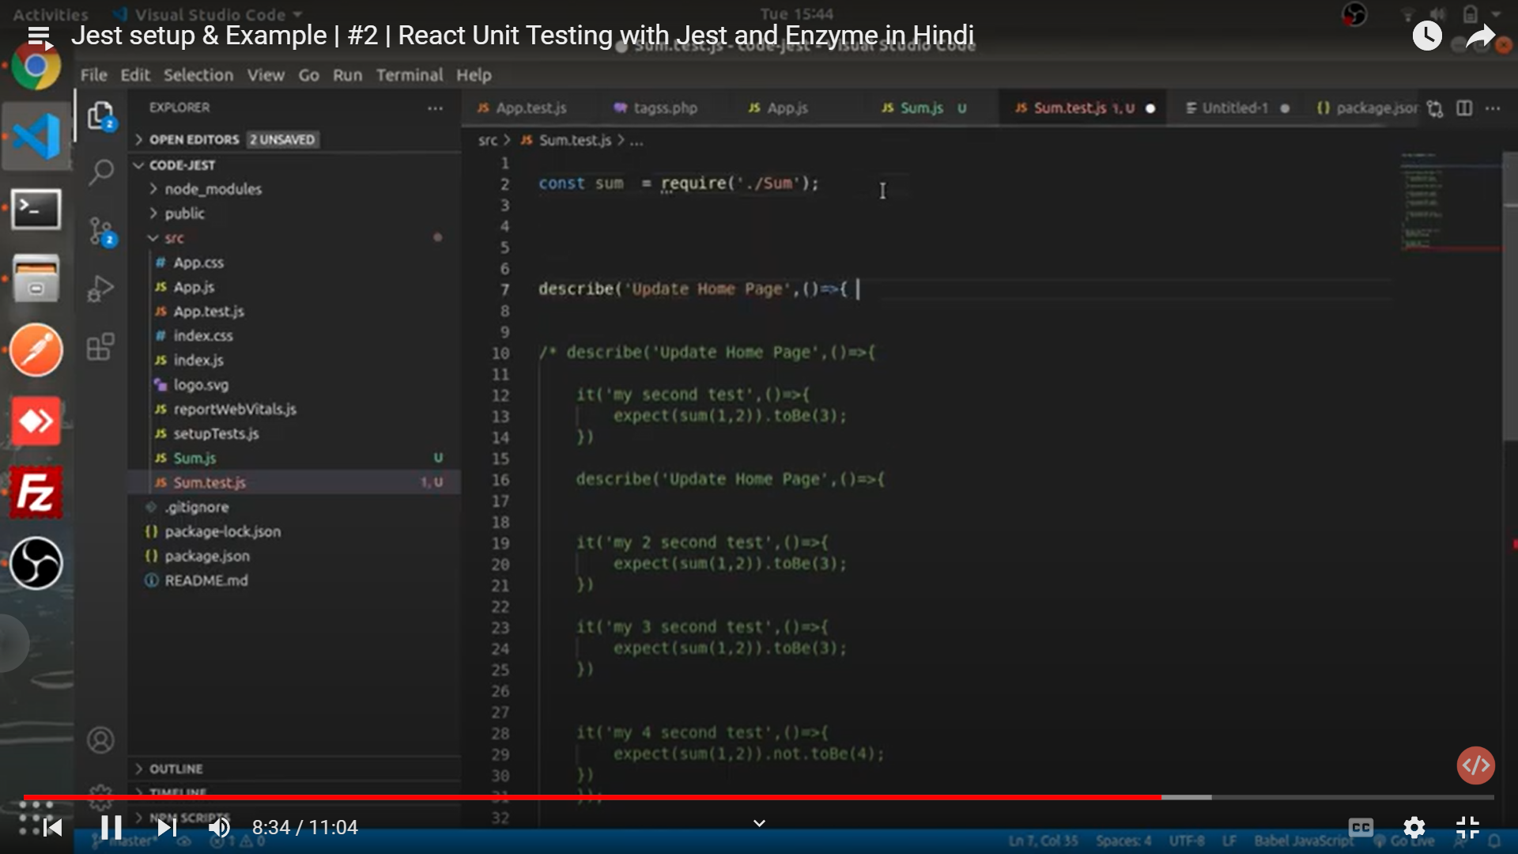

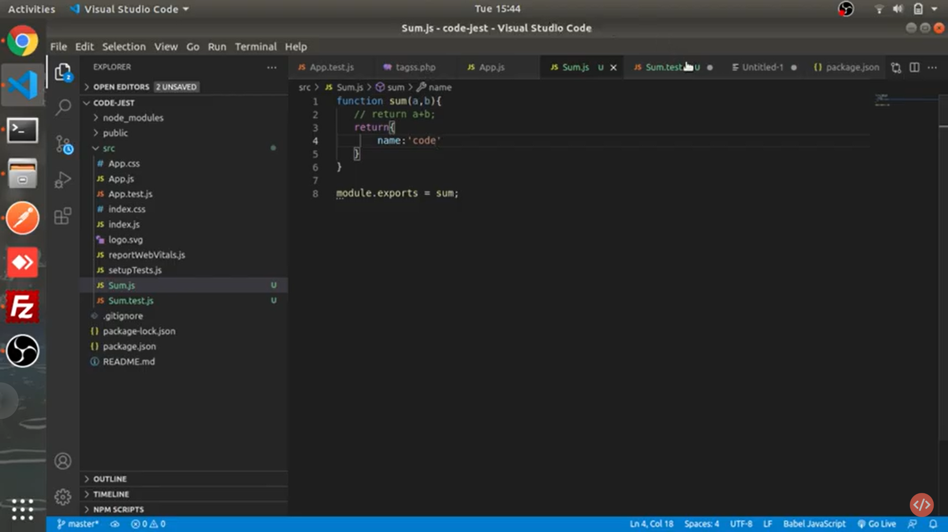

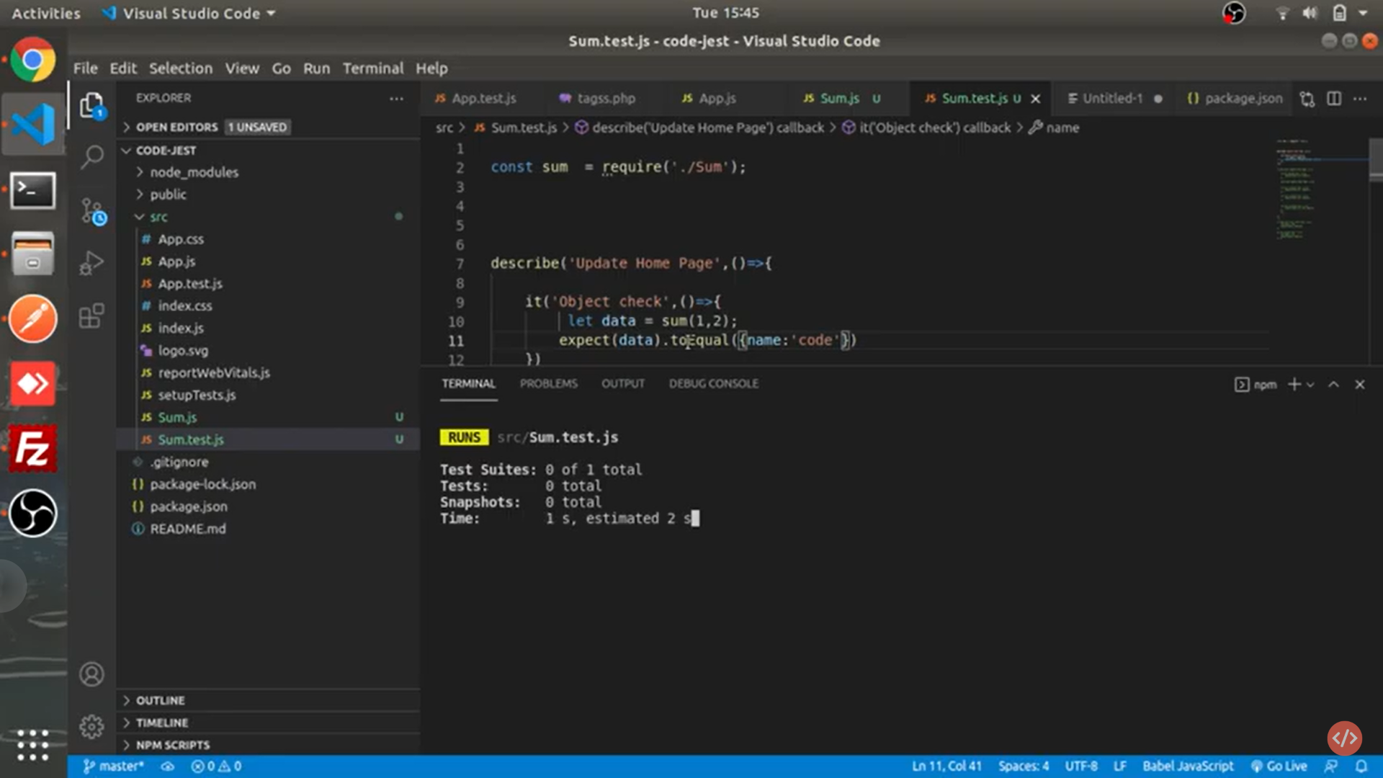

Home.js

import React from 'react'

export default function Home() {

  return (

    <div className='home'>Home </div>

  )

}

[Home.test.js](http://Home.test.js)

import Home from './Home';

import {shallow} from "enzyme";

describe("Test Suite", ()=>

{

  it("home ", ()=>

  {

    let wrapper = shallow(<Home/>)

    console.log(wrapper);

})

})

import Home from './Home';

import {shallow} from "enzyme";

describe("Test Suite", ()=>

{

  it("home ", ()=>

  {

    let wrapper = shallow(<Home/>)

    console.log(wrapper.debug());

    expect(wrapper.exists('.home')).toEqual(true)

})

})

import About from './About'

import {shallow} from "enzyme"

describe("TE", ()=>

{

it("testing class",()=>{

let wrapper=shallow(<About/>)

expect(wrapper.state()).toEqual({name:'Ajay', age:20})

})

it("testing class1",()=>{

  let wrapper=shallow(<About/>)

  expect(wrapper.contains(<div className='hello'>About</div>)).toEqual(true)

  })

})

it("testing class2",()=>{

  let wrapper=shallow(<About/>)

  expect(wrapper.contains(<div className='hello'>About</div>)).toEqual(true)

  })

  it("testing class3",()=>{

    let wrapper=shallow(<About/>)

    expect(wrapper.containsMatchingElement(<div>About</div>)).toEqual(true)

    })

